e-commerce site focusing on Jewelry and Apparel. Will also focus checkout with stripe.

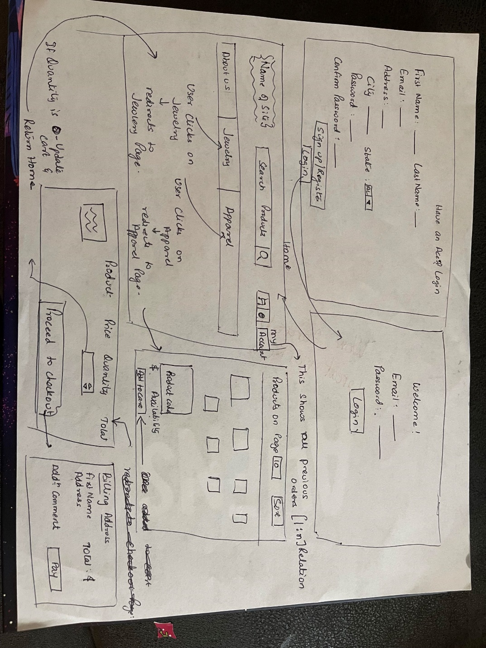

Github repo link: <https://github.com/kpriyaila/Project>

